**How to calculate Subtotals in SQL Queries**

A subtotal is a figure that shows the sum of similar sets of data but it does not indicate the final total.

**RollUP:**

ROLLUP is like a tool in SQL that helps you create organized subtotals for your data. It arranges these subtotals in a hierarchy based on the columns you choose. Additionally, it adds a final row that shows the total of everything, summarizing the entire dataset. So, it's a way to quickly see both detailed and overall summaries of your information.

Example:

In this Example we are creating a Table data name ‘**COURSE’**

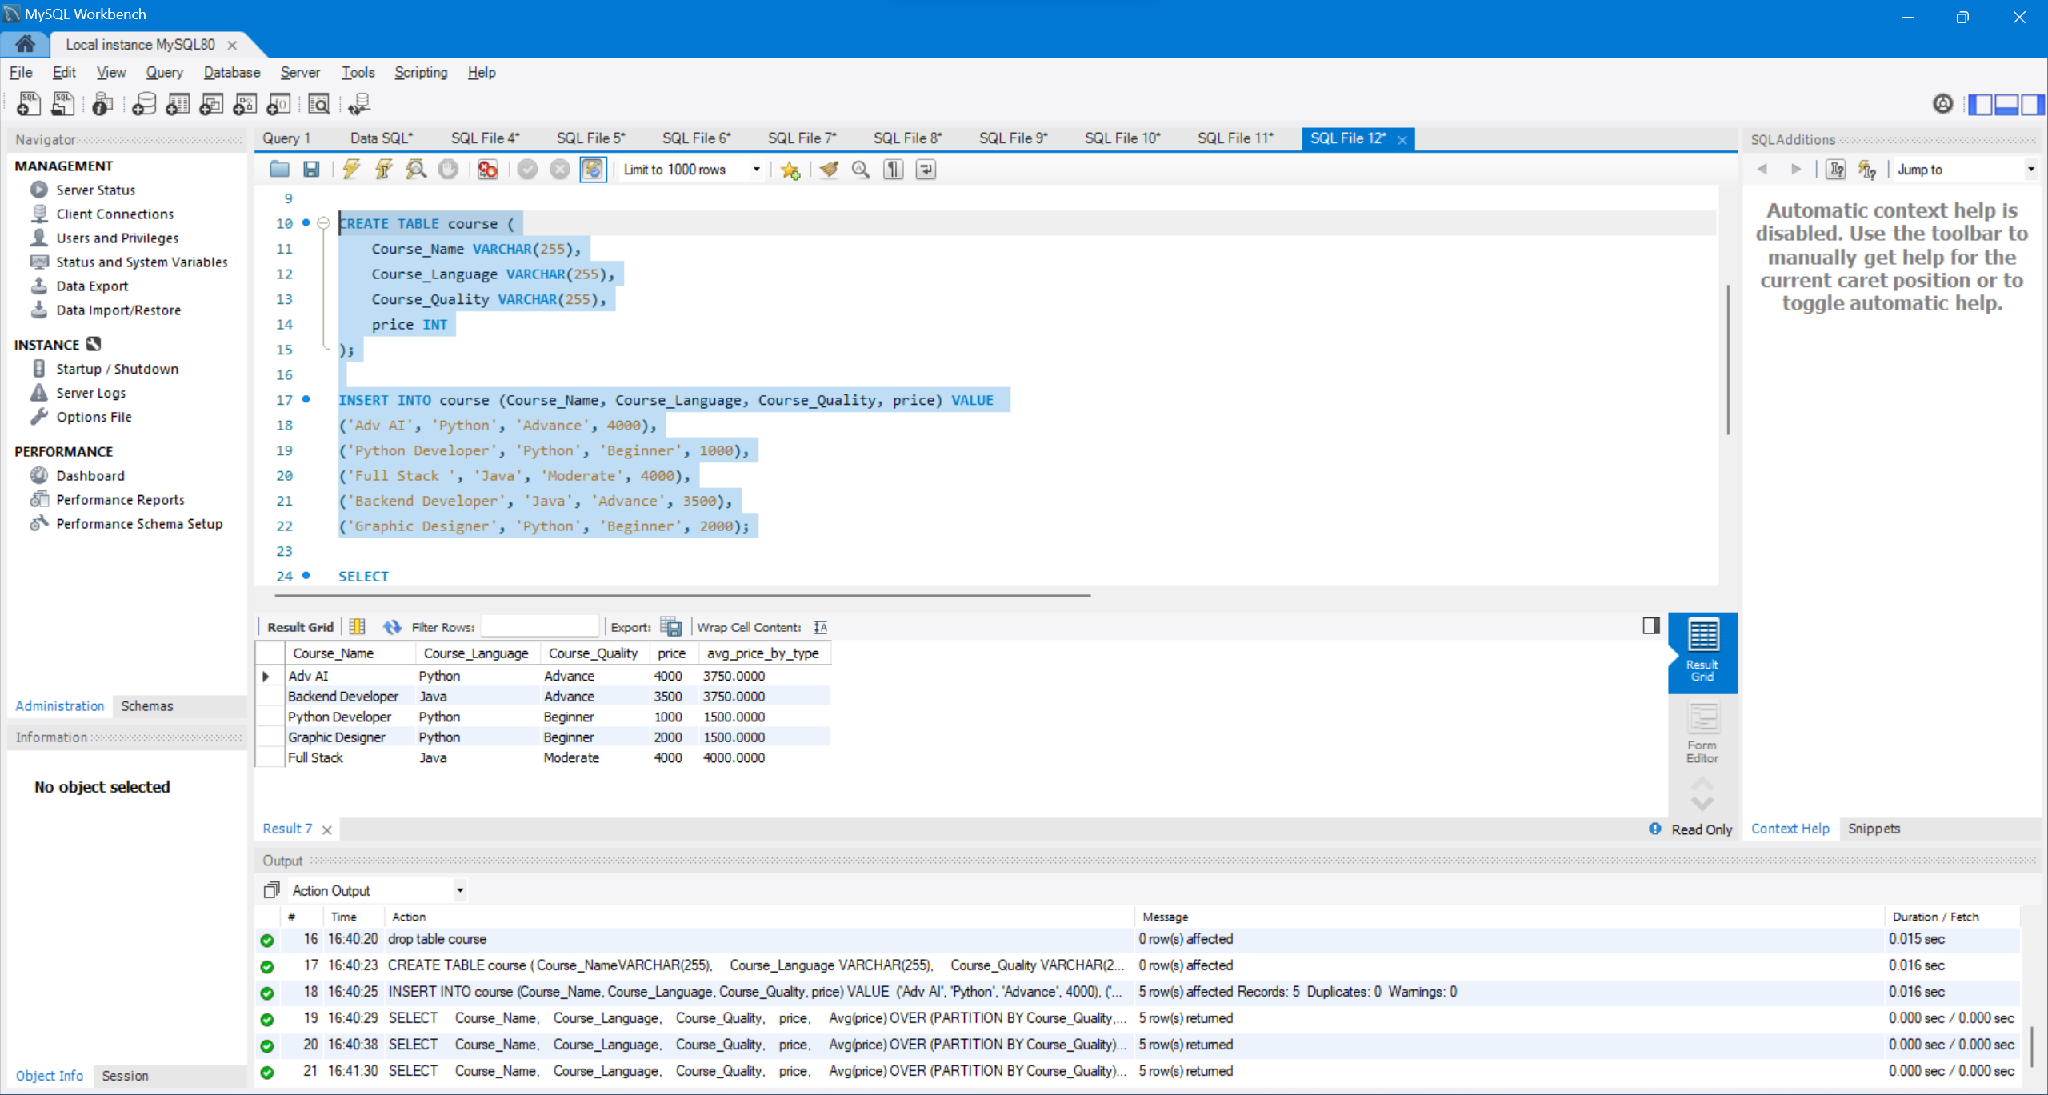

And We are calculating the total price of each category that is the subtotal using RollUp extension

**CODE:**

SELECT

Course_Language,

Course_Quality,

SUM(price) AS Subtotal

FROM

course

GROUP BY

Course_Language, Course_Quality

WITH ROLLUP;

**Output:**

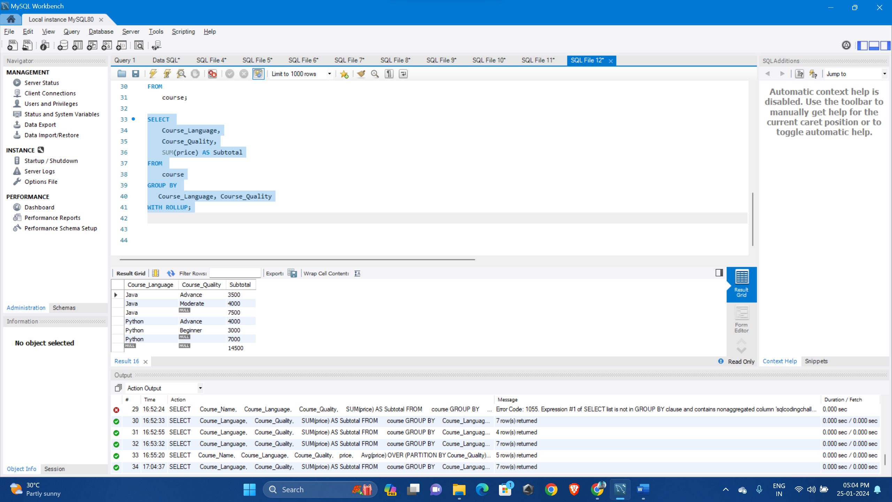

**We can observe from the above example the rollup extension is providing the subtotal based on course_quality attribute**